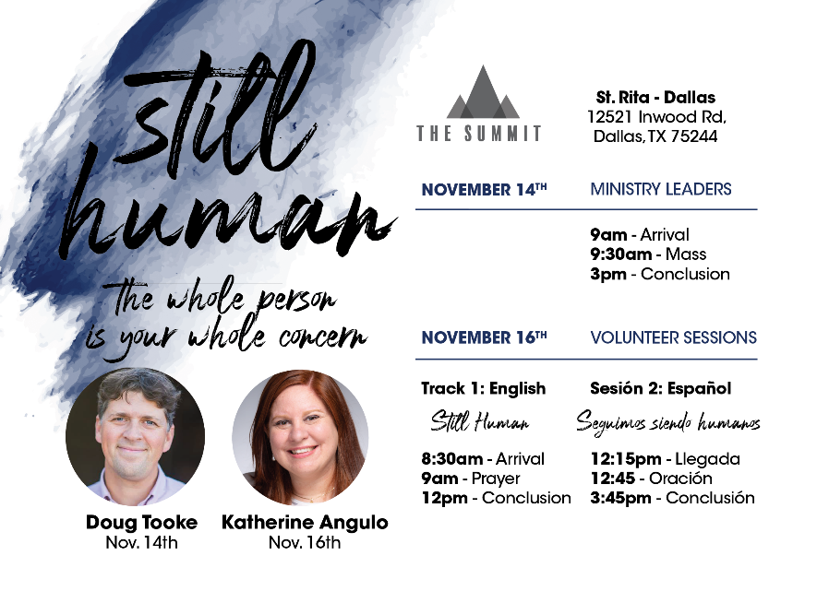
The Diocesan Office of Youth, Young Adult, and Campus Ministries would like to invite all of the volunteers who serve young people (middle school age- young adult age) to its formation day, called “The Summit”!
This particular day is JUST for you- our volunteers! It is completely free and will be an excellent opportunity to receive formation as a minister. There are two tracks- English and Spanish. Please see the schedule below and RSVP for the track you want.
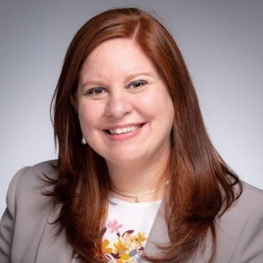
Theme: Still Human
As we know, it’s not enough to teach our young people the “Hail Mary” and send them on their way. The people we serve lead human lives, with human needs, and human problems. At this gathering, we will make a case for why the concerns of modern Christian ministry (and Jesus) involve the care of the whole person.
Speaker: Katherine Angulo
Born in Mexico and raised in Colombia, Katherine now lives in Indiana where she is the Program Director of the Thriving in Ministry Initiative. She has 19 years of ministry experience and wisdom to share.
Saturday, November 16th
English Track – 8:30 AM to 12:00 PM
Link to RSVP: https://oyyacm.breezechms.com/form/November14Summit15

Spanish Track– 12:15 PM to 3:45 PM
Link to RSVP:
https://oyyacm.breezechms.com/form/November14Summit1533
Location: St. Rita Catholic Community in the Parish Commons Building
12521 Inwood Road, Dallas
See Map in Separate Attachment
Light Snacks & Drinks Provided

